[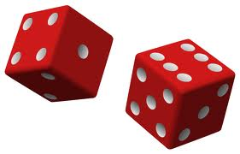](http://www.google.com/imgres?q=dice&um=1&hl=en&sa=N&biw=1170&bih=771&tbm=isch&tbnid=i5fld6OGKfblkM:&imgrefurl=http://en.wikipedia.org/wiki/File:Two_red_dice_01.svg&docid=MvCHGToGWrnUVM&w=671&h=430&ei=Wex3TpuNKuGQsALfo9TODQ&zoom=1&iact=rc&dur=2&page=1&tbnh=101&tbnw=158&start=0&ndsp=26&ved=1t:429,r:5,s:0&tx=120&ty=41)

Write a complete Java program that simulates the rolling of a pair of dice. The program should:

1. Generate two random integers between 1 and 6 (inclusive). I specifically want these stored in two integer variables (not double variables.) Note that there’s no keyboard input.
2. Print out the result of each die **and** the total roll (the sum). For example:

You rolled a 2 and a 5

The total is 7

1. Test-run the program enough times to make sure the lowest roll of a die is 1 and the highest is 6.